

PW Vishwas Diwas

GIVE 25 %

DISCOUNT ON EVERY BATCHES





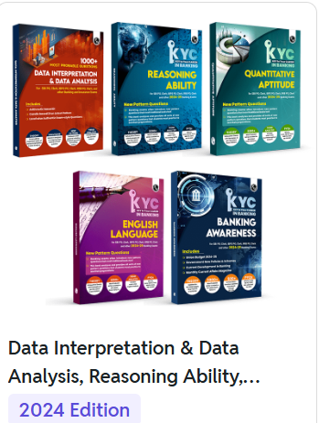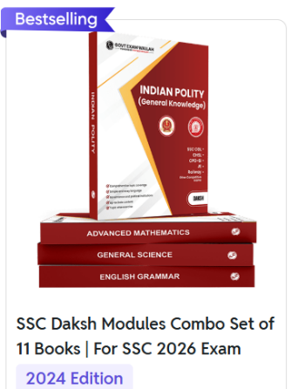

Rs. ~~999~~ 50 %

Rs. 500

Rs. ~~6000~~  50 %

Rs.3000

Rs. ~~3500~~ 50%

Rs.1750

Rs.~~5000~~ 50 %

Rs. 2500

Rs.~~4000~~ 50 %

Rs.2000

Rs.~~2600~~  50 %

Rs.1300